# STONY BROOK UNIVERSITY

# ELECTRICAL and COMPUTER ENGINEERING

# SENIOR DESIGN PROJECT (2016-2017)

# Title: Mosquito zapper

# Supervising Professor: David Westerfeld

# Description:

The world’s deadliest animal is the mosquito (Figure 1). Recent concerns about the Zika virus have attracted a great deal of media attention, but other mosquito borne diseases, particularly Malaria, remain far bigger threats worldwide with an annual fatality count of 725 000 people.

Bug zappers are one method of insect control. Bugs are typically attracted into the device using an ultraviolet light and, sometimes, chemical bait. Once inside the trap they are killed with a high voltage electric shock. The problem with this approach is that while many bugs are attracted to UV light, mosquitoes are not. As a result, many harmless or even beneficial bugs are killed in bug zappers with minimal effect on the mosquito population. A study by the University of Delaware cited by Wikipedia found that only 31 of 13 789 insects killed in traps were biting insects.

This project involves the creation of a better ~~mouse~~ mosquito trap. Since mosquitoes find their victims by tracking exhaled carbon dioxide, a suitable attractant might be a simple candle, CO2 cartridge, or chemical bait from a commercial zapper.

What will make this project different is the addition of a microphone and digital signal processing (DSP) capability that will only activate the high voltage if a mosquito is detected by sound. Mosquitoes find mates using sound[1] – the pitch of their wing beats identifies both the sex and the species of the mosquito. Your system will record the number, sex, and species of mosquitoes killed in the trap. A probable kill will be recorded if:

1. a mosquito sound is detected
2. a current surge (or perhaps zapping sound) is detected
3. the mosquito sound ceases

Statistics will be displayed on the unit. Optionally, if a large team is available, the data will be wirelessly relayed to a cell phone application.

The high voltage utilized in this project (typically 4kV) presents a safety risk. In addition to mechanical barriers, the high voltage generator must be designed to limit the current so that large animals (e.g. students) are not injured by accidental contact.

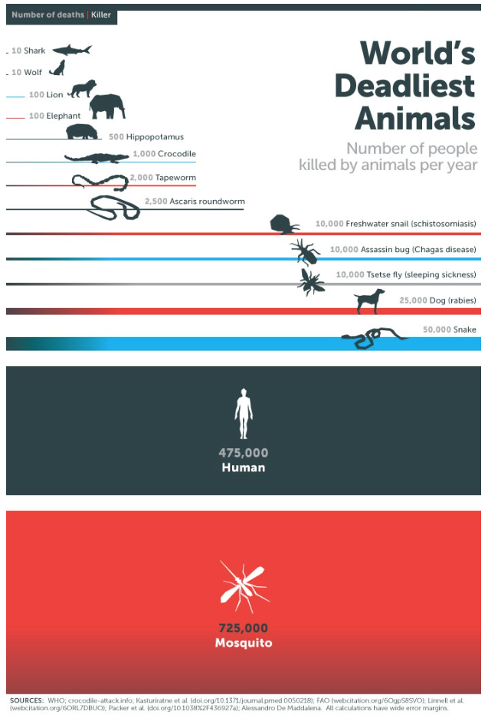

Figure 1: http://www.businessinsider.com/bill-gates-mosquitoes-deadliest-animals-2016-2

**Requirements:** Analog electronics for the microphone amplifier, DSP for the detection algorithm, power electronics for intrinsically safe high-voltage source, applications programming for the cell phone interface.

# Project cost: $250

**Suitable for**

___X___ Computer Engineering

______ Microelectronics Track in EE

___X___ Telecommunications Track in EE

1. http://www.ncbi.nlm.nih.gov/pmc/articles/PMC2975882/